
ALPINE CHAPTER NON-TYPICAL GUN RAFFLE

- Only 500 tickets will be sold for a chance to win 5 guns; the winner gets all 5 guns.

- Tickets $30 each or 4 for $100.

- Winner will be drawn on September 12th during the 3rd Annual MDF Alpine Chapter Banquet at the Alpine Civic Center. Doors Open @ 5:30 p.m. – Dinner @ 7:30 p.m. – Live Auction to follow dinner – Non-Typical Gun Raffle winner at 10:00 p.m. Winner does not have to be present to win.

- For Tickets Contact Either: SHAWN GRAY 432-296-3724 or MARK GARRETT 432-386-5096

Raffle guns
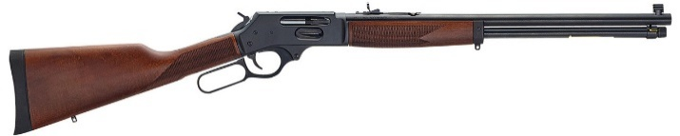
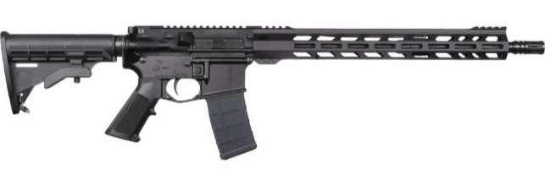
Henry Side Gate – .360 Buckhammer
ZRO Delta RS15 V2 AR-15 – 5.56 NATO
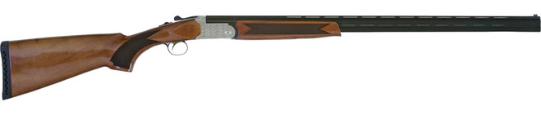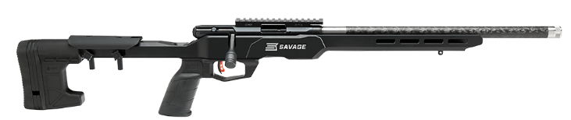
Tri Setter 20M/26MC O/U Shotgun – 20 Gauge Savage B17 Precision Lite – .17 HMR

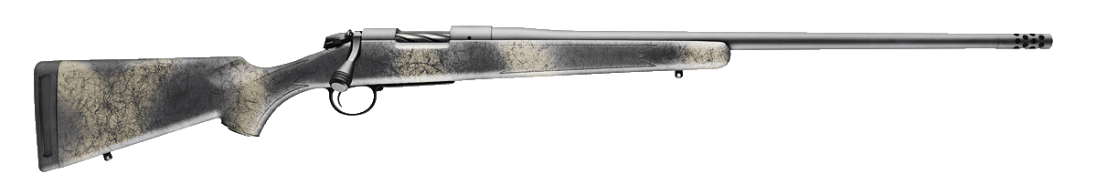
Bergara Wilderness Ridge – 6.5 PRC

ALL STATE AND FEDERAL LAWS APPLY ON FIREARMS

